# Third Year B. Tech (EL & CE)

**Semester: V Subject:** Data Base Management System

**Name: Shreerang Mhatre Class: TY**

**Roll No: 52 Batch: A3**

# Experiment No: 04

**Name of the Experiment**: **SQL DML Statements**

**Performed on: 13/09/2023**

**Submitted on: 27/09/2023**

**Problem Statement:**

(INSERT,UPDATE,DELETE and SELECT QUERY) on Company Database)

Code:

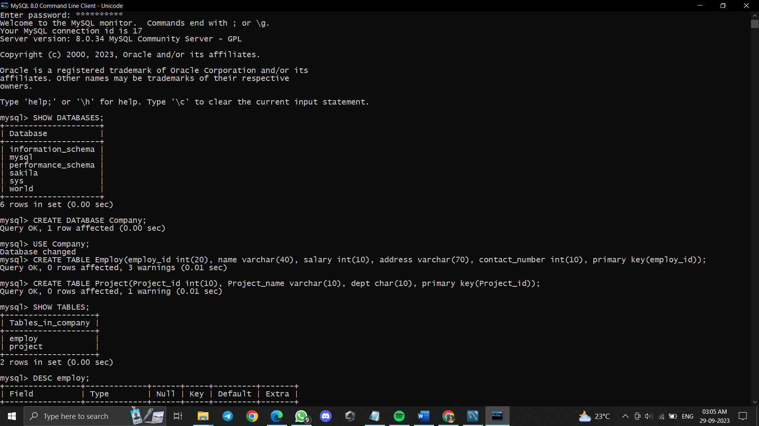

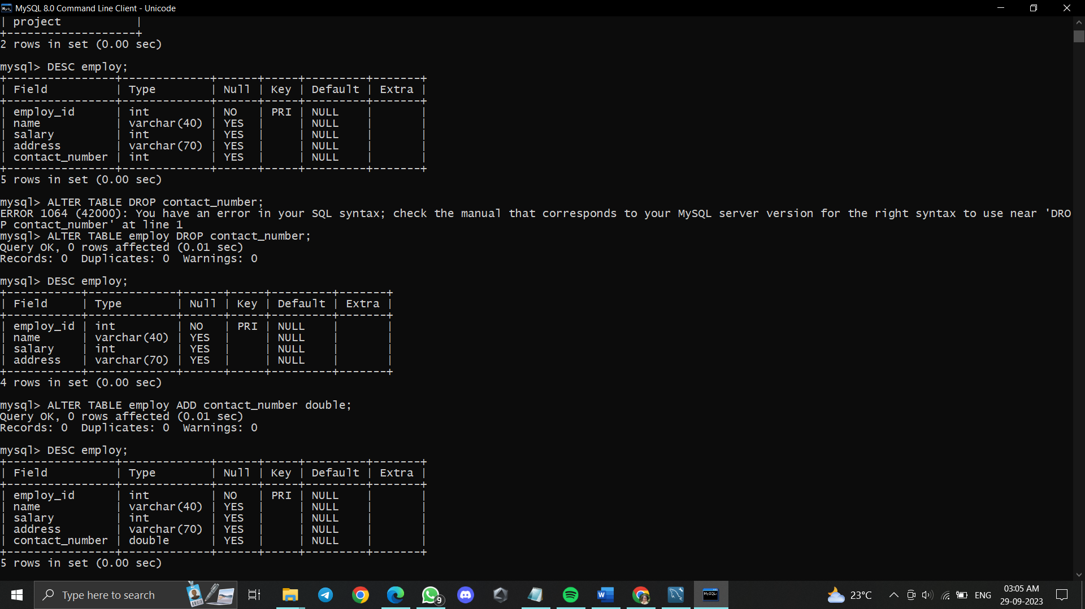

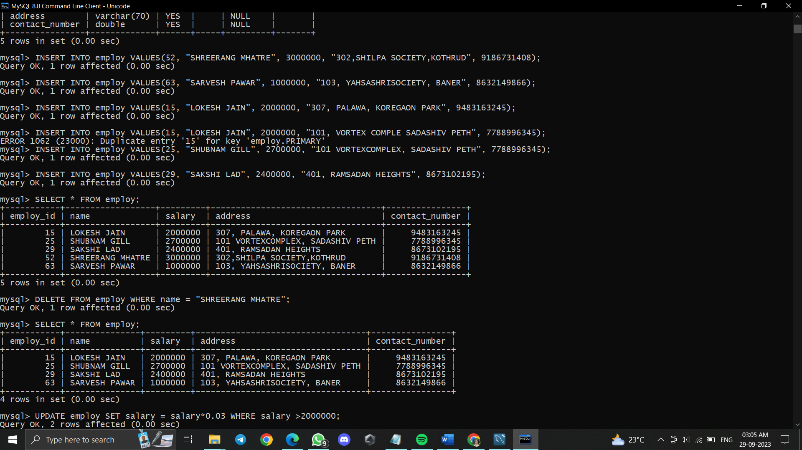

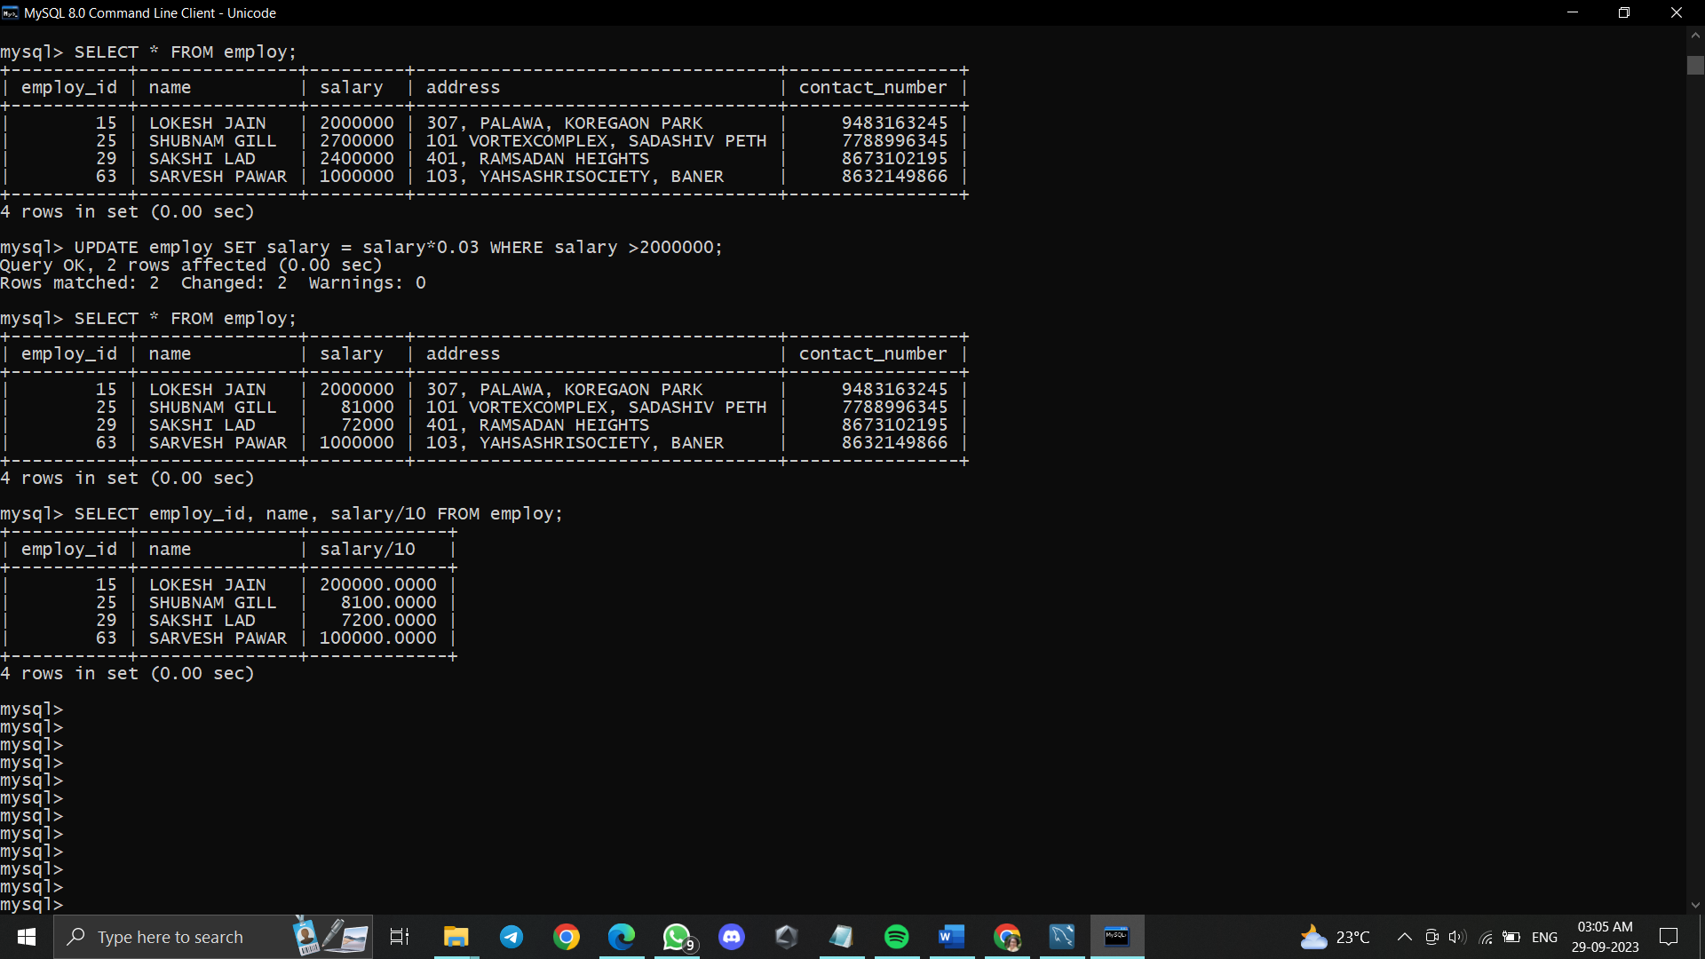

**Post Lab Questions:**

